# Residential Portfolio Analytics: Revenue Optimization & Portfolio Performance Dashboard
OR
Residential Portfolio Analytics
End-to-End Business Intelligence Project for Revenue Optimization and Portfolio Performance

**Tools:** Excel • MySQL • Power BI • DAX • Power Query

The dashboard below provides an executive overview of portfolio performance, highlighting occupancy, revenue, receivables, maintenance, and revenue optimization opportunities.
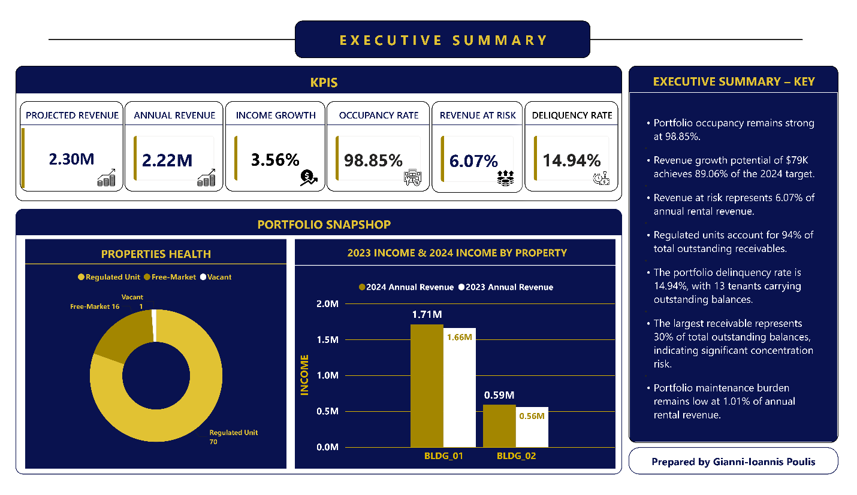## Project Overview
This project demonstrates the design and implementation of an end-to-end Business Intelligence solution that integrates Excel, MySQL, and Power BI to transform residential property portfolio data into actionable business insights.

Project at a Glance
Metric | Value
Residential Buildings | 2
Apartments | 87
Core SQL Tables | 6
Analytical Views | 13
Business Analysis Queries | 7
Power BI Report Pages | 5
DAX Measures | 28
Data Sources | Excel, MySQL
Technologies | Excel, MySQL, Power BI

EXCEL DASHBOARD
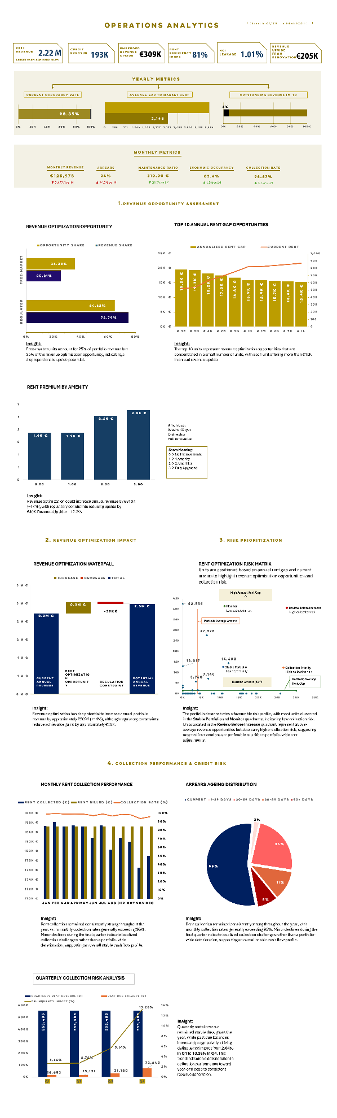

## Business Problem
Residential property portfolios often contain hidden revenue opportunities caused by below-market rents, long-tenure leases, and operational inefficiencies. At the same time, property managers must monitor tenant arrears, maintenance costs, and portfolio performance while while supporting operational and investment decision-making.
## Business Questions:
This project was developed to provide answers to 3 key business themes:
Revenue Optimization
- How much revenue is currently generated by the portfolio?
- Where is the greatest revenue optimization opportunity?
- Which units offer the highest revenue upside through rent increases or renovation?
- How efficiently is the portfolio capturing rent relative to legal benchmark levels?
Collection Risk
- Which tenants represent the highest collection risk?
Maintenance Performance.
- What financial impact do maintenance costs have on portfolio performance?

Project Workflow

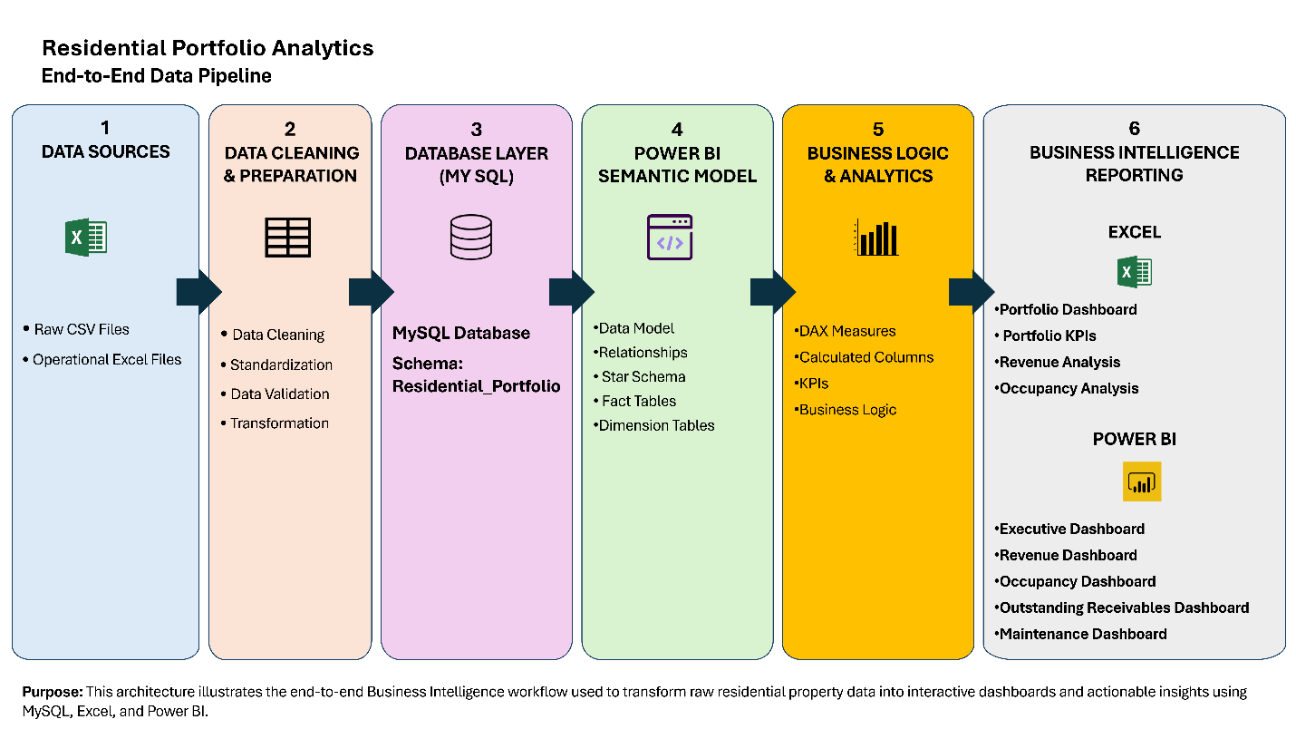

Dashboard Overview
The Power BI solution consists of five interactive report pages designed to answer different business questions.
Executive Summary
Provides an executive overview of portfolio performance through KPI cards, occupancy metrics, revenue comparison, maintenance indicators, and key business insights.

Portfolio Performance
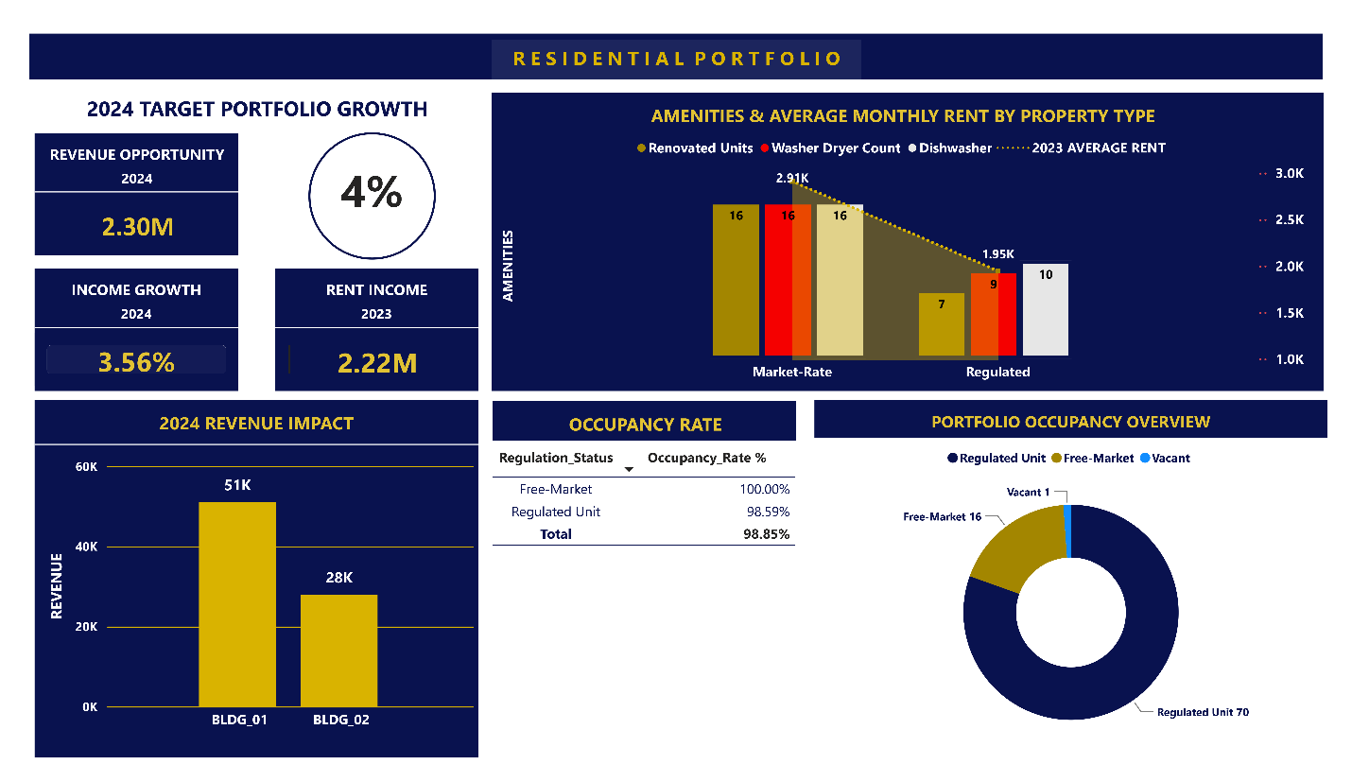Evaluates portfolio composition, occupancy, rental income, property mix, and apartment amenities to support operational decision-making.

Revenue Optimization
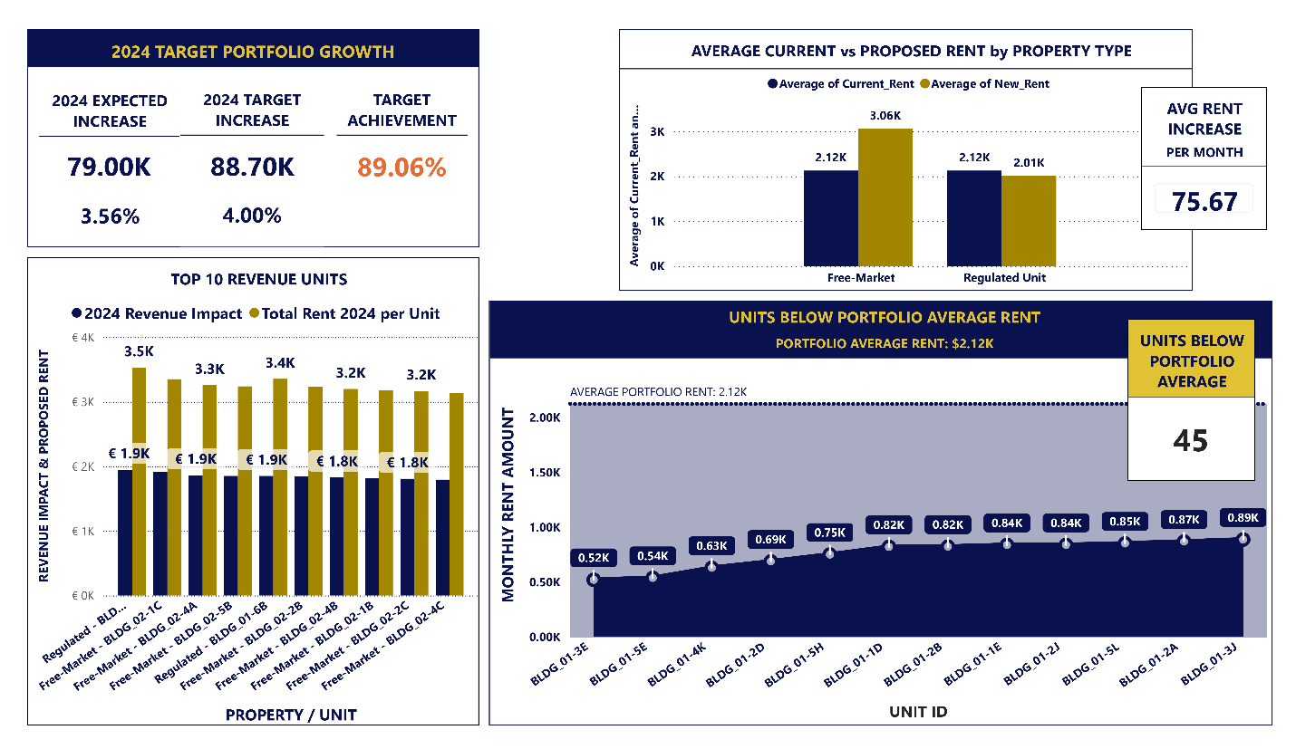Identifies embedded revenue opportunities by comparing current rents against legal market rent levels and highlighting units with the greatest revenue potential.

Outstanding Receivables
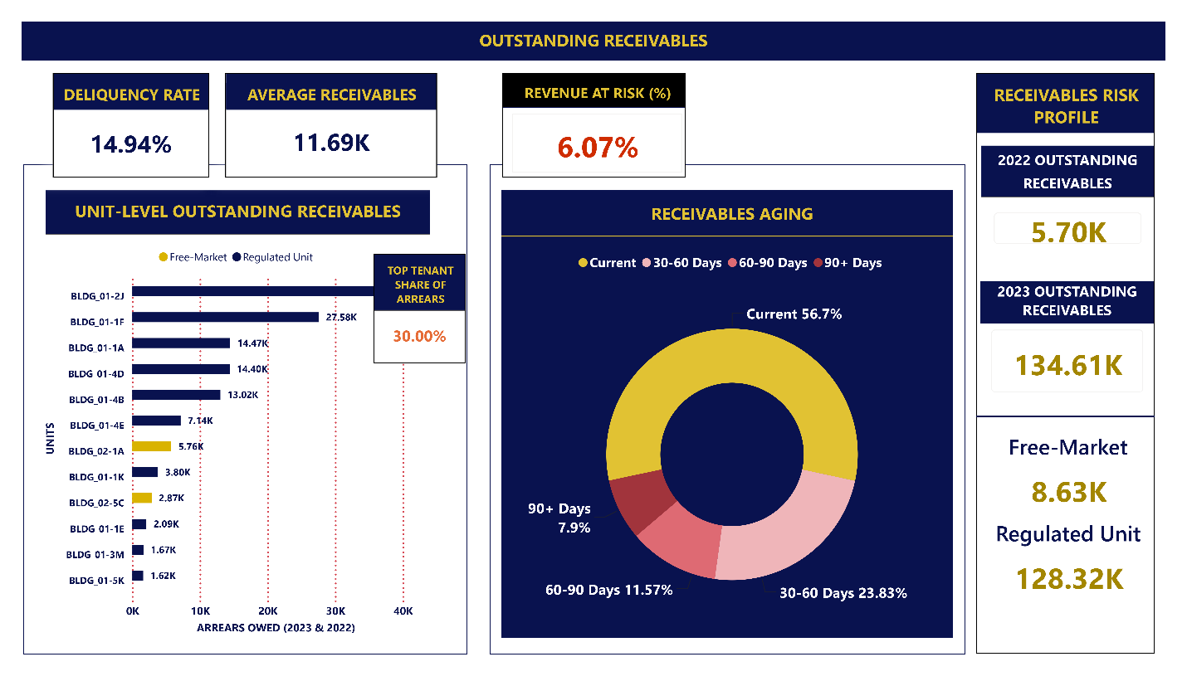Measures collection performance, delinquency, receivables concentration, tenant risk, and outstanding balances to support credit risk management.

Maintenance Analysis
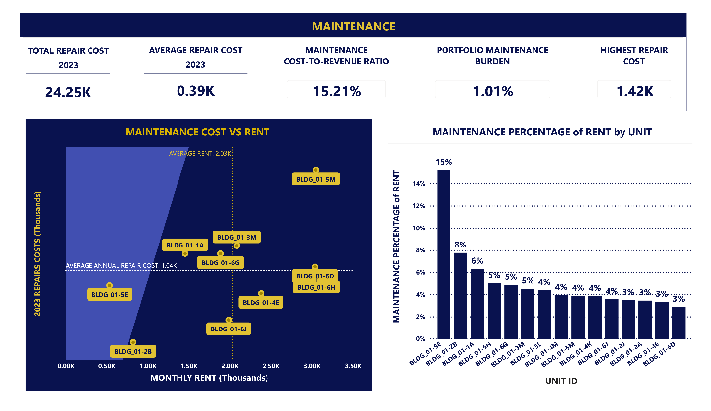Evaluates maintenance expenditure, repair cost per unit, maintenance burden, and operational efficiency across the residential portfolio.

Business Impact
The analytical solution generated several actionable business insights:
Portfolio Performance
- Confirmed a strong occupancy rate of 98.85%.
Revenue Optimization
- Identified over €309K in embedded annual revenue upside.
- Quantified €407K in theoretical annual revenue opportunity from legal rent gaps.
- Identified €79K in unrealized annual rental revenue opportunities.
- Prioritized long-tenure units representing approximately €207K in additional revenue potential.
Credit Risk
- Measured revenue at risk at 6.07% of annual rental revenue.
- Revealed that 94% of outstanding receivables originate from regulated units.
- Identified a significant concentration risk, with one tenant (BLDG_01 Apt # -2J ) accounting for 30% of total outstanding receivables.
Operational Performance
- Confirmed a low maintenance burden of 1.01% of annual rental revenue.
Recommendations
- Review 13 low-rent units (<€1,000) for potential rent adjustments.
- Prioritize long-tenure units (>10 years) for phased rent optimization.
- Strengthen collection strategies for high-risk tenants.
These findings provide management with clear, data-driven insights to improve revenue performance, prioritize collection efforts, optimize maintenance planning, and support investment decisions.
Skills Demonstrated
Skill Area | Skills Demonstrated in this Project
Project Management | Designed and executed an end-to-end analytics workflow spanning six phases, from data acquisition and preparation to analysis, dashboard development, and business communication.
Data Collection | Digitized paper-based rental ledgers and consolidated them into a structured dataset for analysis and reporting
Data Preparation & ETL | Cleaned, transformed, standardized, and validated data using Power Query, resolving missing values, inconsistent formats, duplicate records, and data quality issues.
Database Design | Designed and implemented a relational MySQL database, created analytical SQL views, and structured datasets to support reporting and dashboard integration.
SQL Development | Developed analytical SQL solutions using SELECT, WHERE, GROUP BY, HAVING, ORDER BY, LIMIT, CASE expressions, INNER and LEFT JOINs, Common Table Expressions (CTEs), subqueries, views, aggregate functions, window functions (RANK), NULL, ROUND, staging tables, and data validation techniques.
Feature Engineering | Engineered analytical features and calculated metrics to support rental performance analysis, occupancy monitoring, payment tracking, and property comparisons.
Data Analysis | Analyzed rental performance across 2 residential buildings and 87 apartments, evaluating rent payments, lease activity, apartment amenities, property characteristics, and differences between regulated and free-market units.
Business Intelligence | Delivered business intelligence solutions that transformed raw operational data into actionable insights through reporting, visualization, and performance monitoring.
Dashboard Development | Designed executive dashboards that communicated key performance indicators, rental trends, occupancy metrics, and operational insights for decision-making.
Power BI Development | Created 28 DAX measures, dynamic KPI reporting, interactive slicers, filters and report navigation.
Excel Development | Built advanced Excel dashboards using PivotTables, Pivot Charts, Power Query, INDEX-MATCH, SUMIFS, COUNTIFS, Data Validation, Conditional Formatting, Named Ranges, and interactive dashboard controls.
Business Communication | Presented analytical findings through clear visualizations, dashboards, and executive summaries, translating complex data into actionable business recommendations.
Documentation | Produced comprehensive technical documentation including SQL documentation, DAX documentation, architecture diagrams, workflow diagrams and GitHub project documentation.
Version Control & Portfolio Development | Organized the project using GitHub with a professional repository structure, reproducible SQL scripts and comprehensive README documentation.

Repository Structure

Residential-Portfolio-Analytics/

│

├── README.md

│

├── Documentation/

│ └── Residential_Portfolio_Analytics_Report.pdf

│

├── Excel/

│ ├── Residential_Portfolio_Prototype.xlsx

│ └── Excel_Dashboard.png

│

├── SQL/

│ ├── 01_Create_Tables.sql

│ ├── 02_Data_Cleaning.sql

│ ├── 03_Views.sql

│ └── 04_Business_Analysis.sql

│

├── PowerBI/

│ ├── Residential_Portfolio.pbix

│ └── Residential_Portfolio_Dashboard.pdf

│

└── Images/

├── Executive_Summary.png

├── Portfolio_Performance.png

├── Revenue_Optimization.png

├── Outstanding_Receivables.png

└── Maintenance_Analysis.png

About the Author
John Alexiou
Business Intelligence | Data Analytics | SQL | Power BI | Excel
GitHub: link
LinkedIn: link

